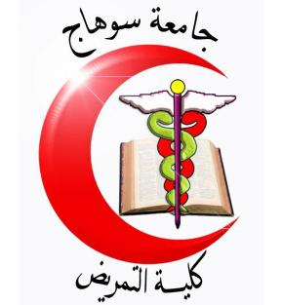

Final Exam of maternal and child health Nursing
First Years Students
Date: / /2016 technical Institution of Nursing
Time: 2 hrs Total Marks: 40 Marks
I-define the following: (3) (3 Marks)
- Pediatric Nursing:
--------------------------------------------------------------------------------------------------------------------------------------------------------------------------------------------------------------------------------------------------------------------------------------------------------------------------------------
II- List the following (1) (4 Marks)
A-Benefits of breastfeeding for infant:
1--------------------------------------
2---------------------------------------
3---------------------------------------

II- Put (T) in front of the correct statement and (F) in front of the false one:
(2) (10 Marks)
1-Weight loss in moderate degree of dehydration is 3-5% | T | F
2- Toddler stage is between 1 to 3 years of age. During this period, growth slows considerably. | T | F
4- Production of spermatozoa (which is sign of puberty)is a secondary sex characteristics in boys: | T | F
7- Oversensitivity to gas is considered one of causes of colic. | T | F
9- Problems may occur during adolescence include early or delayed puberty. | T | F

III-choose the correct answer from the Following: (8 Marks).
1- Infant care include:
- Anorexia.
- Attention deficit.
- Anger issues.
- Bathing for clean
2-Health Problems of Preschool except:
  - Stress.
  - Thumb-Sucking.
  - Enuresis.
  - Activity
3-Secondary sex characteristics in girls:
- Increase in transverse diameter of the pelvis.
- Change in the vaginal secretions.
- Change in voice.
- Rapid growth of shoulder breadth.
- (1-2)
4-Adolescent Teaching:
- Bacterial infection.
- Substance use and abuse.
- Gang activity.
- Development of the breasts.
- (2-3)

IV-Read the words in column (A) and Wright the it's correct number at the relevant statement in column (B): (1.5) (15 Marks)
Column (A) | Column (B)
1- Development  2-Abdominal pain and blood in stool  3-Adolescent  4- Dehydration  5- Blinking reflex  6-Vomiting  7-Pediatric Nursing  8- Types of Growth  9-Needs of infant  10-Bacterial infection | ( ) - It is aroused when the infant is subjected to light.  ( ) Need for feeding. Suckling pleasure &.warmth& comfort and love& security.  ( ) - giving assistant , caring and support to the growing and developing children o achieve their individual potential for functioning with fullest capacity  ( ) – are consider warning signs of severe diarrhea  ( ) - refers to progressive increase in skill and capacity of function.  ( ) – is a period from 13 to 18 age years old  ( ) – is a child's body lacks enough fluid  ( ) – is simply the forceful ejection of stomach and its contents from the mouth  ( ) – is one Causes of diarrhea  ( ) Physical growth (Ht, Wt, head & chest & arm circumference). And Physiological growth.

GOOD LUCK
Dr. Manal Mohammed Ahmed

